**Turbine Cooling Water Strainer Inspection Schedules**

Since 2010, NWW projects have been making regular, weekly or monthly, inspections of the turbine cooling water strainers to document occurance of juvenile salmonids and Pacific lamprey. Subsequently, we now have seven years of data showing the numbers and timing of juvenile lamprey that collect on the strainers. Prior to conducting these frequent inspections, the strainers would be inspected only when pressures increased (a few times per year) or during non-routine maintenance. Questions have been raised by operations personnel on how much longer these additional inspections will occur? If the inspections are to continue, what is the additional information to be used for and can the number of inspections be reduced, such as during the summer when few or no lamprey are seen?

The following figures are summaries of the seven year’s of inspection data. In general, we see that the numbers of lamprey collected in the strainers are low (10 or fewer) by early July, except for McNary where numbers decline about one month later, by August. Looking at the cumulative curves, we see that 90% of the lamprey are typically seem by mid-June. Very few lamprey are observed from July to late December in most years.

***Based on these data, not sampling from mid-June until mid-December would likely represent a minimal loss in information on lamprey presence at McNary and the Snake River dams. We also recommend, moving forward, conduct only monthly samplng mid-December to mid June.***

Numbers of juvenile lamprey counted during inspections of tirbine cooling water strainers, 2010-2016.

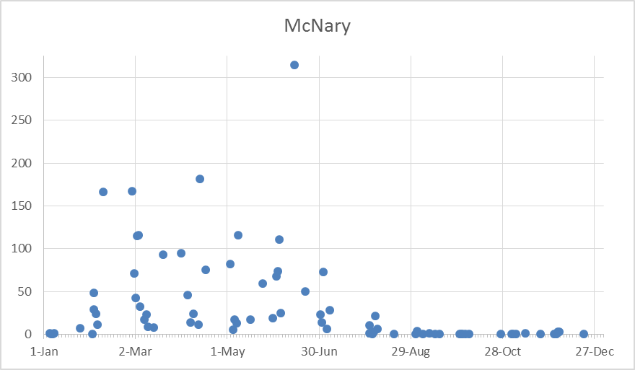

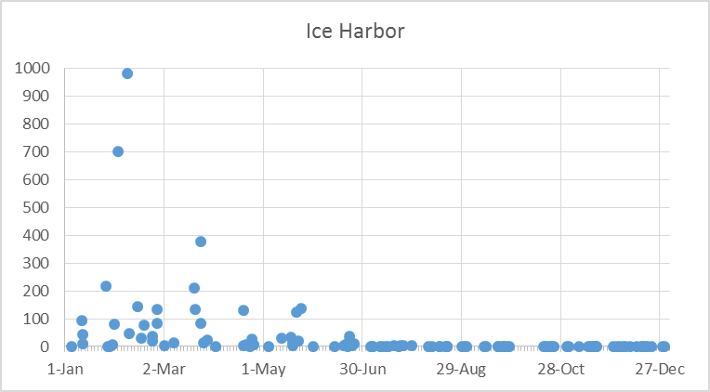

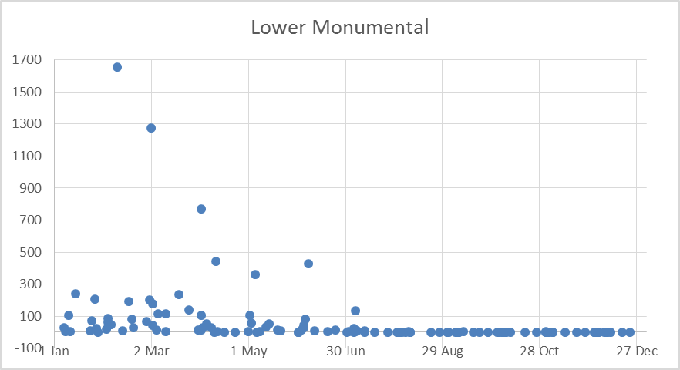

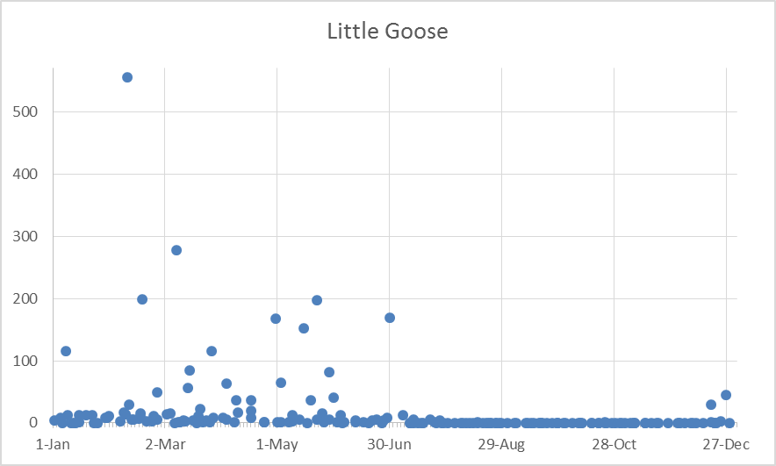

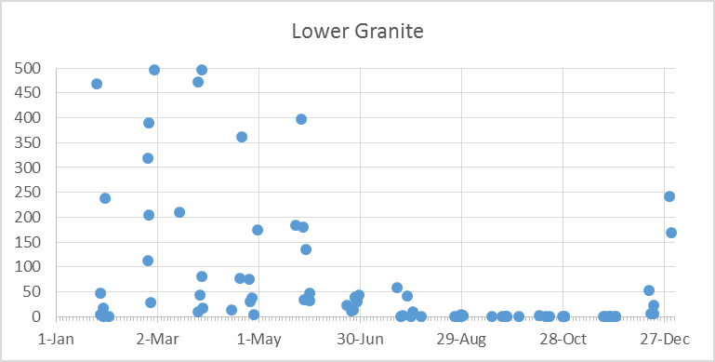

Cumulative number of juvenile lamprey during inspections of tirbine cooling water strainers, 2010-2016.

